### ASSIGNMENT-3

|  |  |
| --- | --- |
| Assignment Date | 02 OCTOBER 2022 |
| Student Name | R.Swathi |
| Student Roll Number | 2019504053 |
| Maximum Marks | 2 Marks |

### TRAFFIC LIGHT CODE:

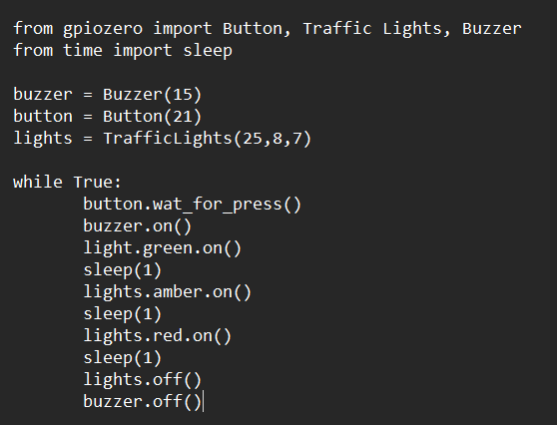

### LED BLINK CODE:

